**Sample Test in TestCafe**

**Description:**

The purpose of this test is to identify the candidates ability to right automation tests using the TestCafe framework.

**Steps:**

1. Install latest version of npm using the below link:

<https://www.npmjs.com/get-npm>

1. Install latest version of Visual Studio code in your machine using the below link:

<https://code.visualstudio.com/download>

1. Install the “TestCafe Test Runner” extension in VS Code.

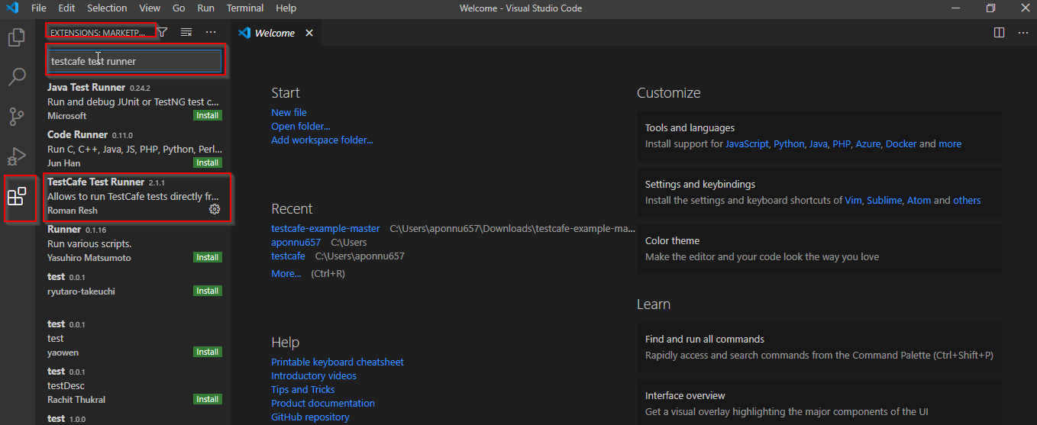

1. Download the code from the below Github Link and unzip the contents:

<https://github.com/qualityshepherd/testcafe-example>

1. Open the folder contents which contains the code in VSCode using the “File >> Open Folder” option and select the folder.
2. Open terminal window using the menu bar - “Terminal >> New Terminal”  in VSCode.
3. Navigate to the folder where the package.json file exists in the terminal window using the command ”cd C:\Users\......\Downloads\testcafe-example-master\testcafe-example-master” command. Note: You should use the folder where the package.json file exists.
4. Type “npm install“ in the command line in the terminal window to install the application.
5. Then type “npm test“ in the command line in terminal window to run all the tests which are present in the codebase.
6. Navigate to the file explorer in VSCode and create a new js file under the tests folder for the new test cases you are gonna write.

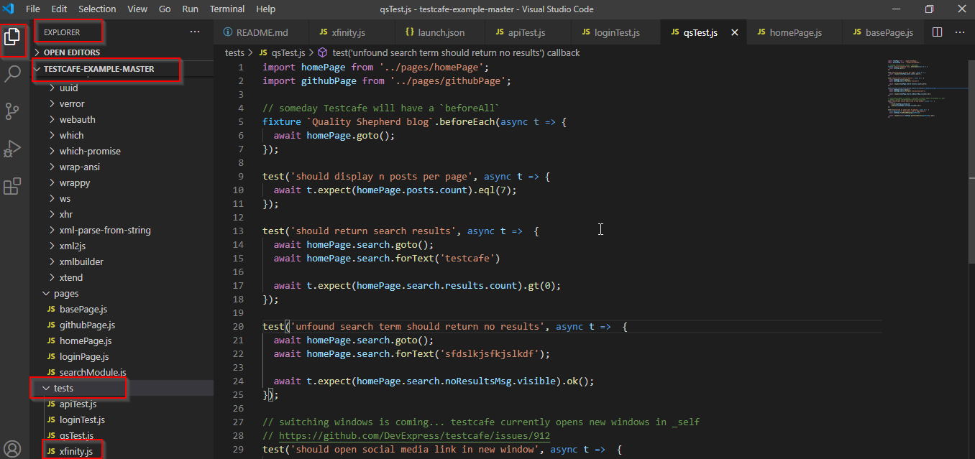

1. Write test scripts in the new js file u created to load the website <https://www.xfinity.com/learn/offers> in chrome browser. Refer to the existing tests to understand how to open a url using testcafe test scripts.
2. Write scripts to enter the address “1555 suzy st, 441, 17046” in the text box.

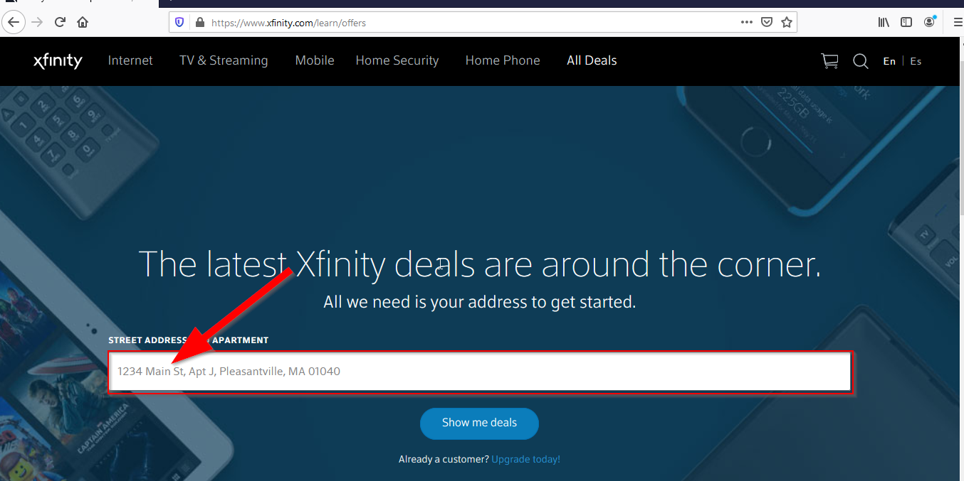

1. Write scripts to select the first intellisense option displayed below the text box:

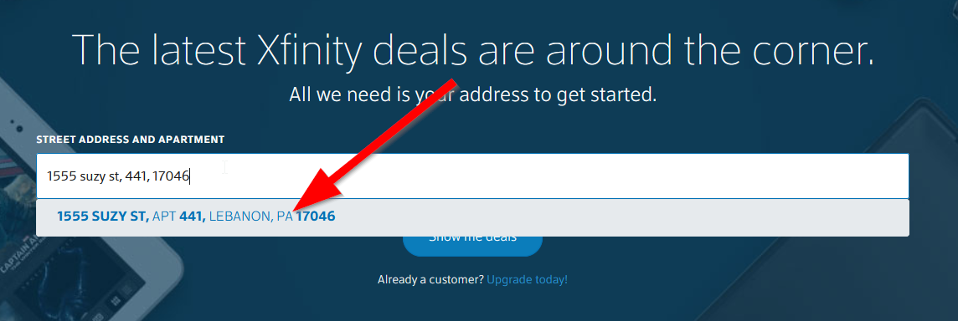

1. Write scripts to click on the “Show me deals” button:

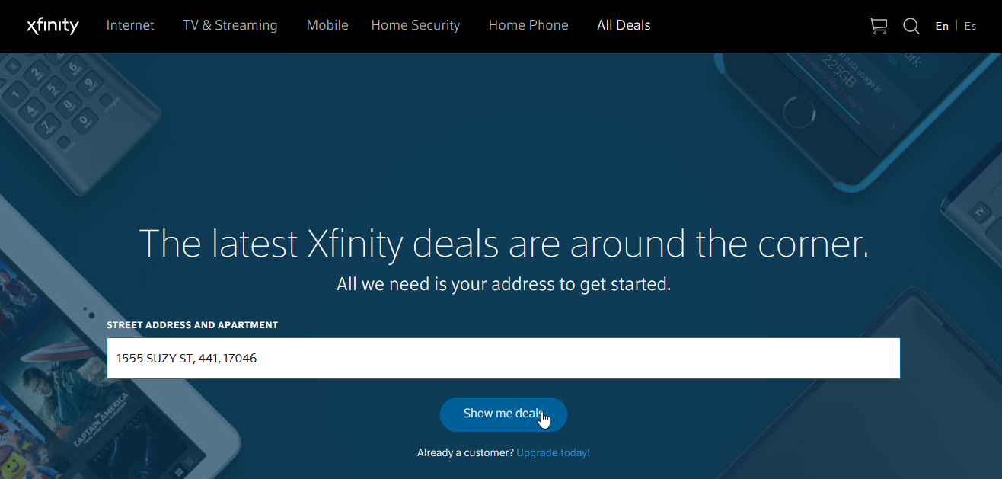

1. Write scripts to click on the first “Add to Cart” button displayed:

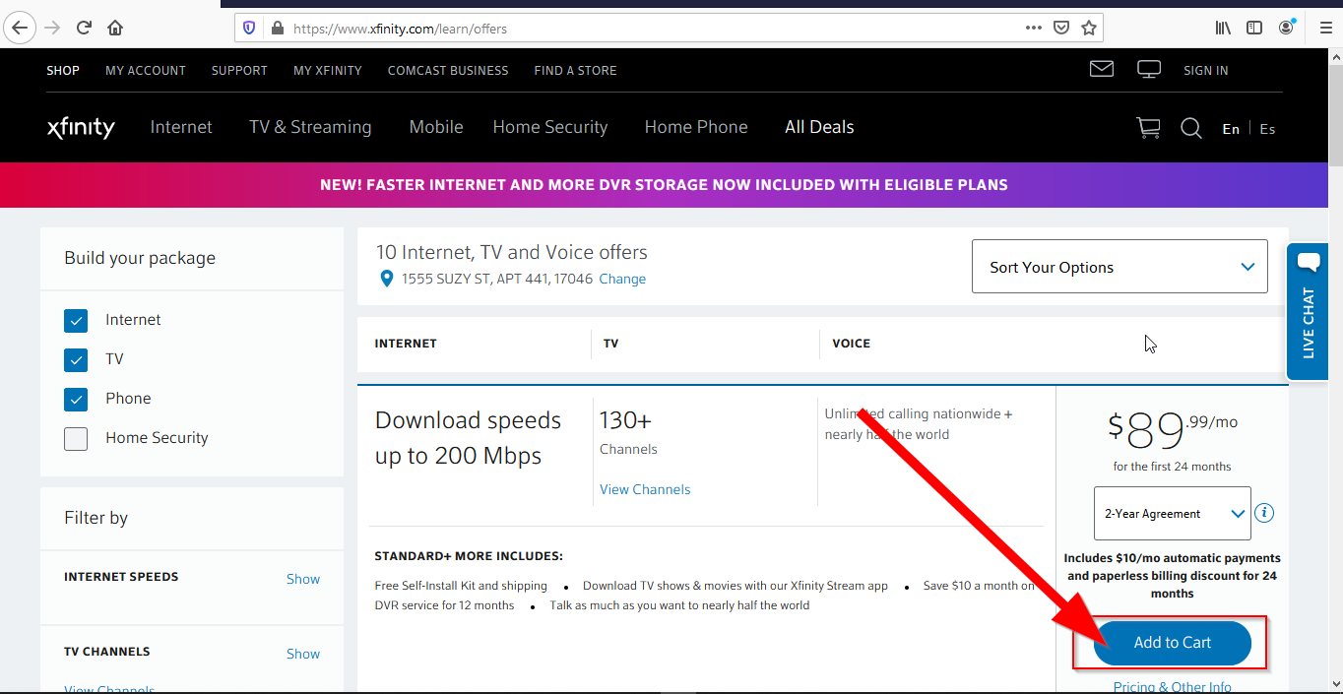

1. Verify the user has landed on <https://www.xfinity.com/buy/video-channels> url.

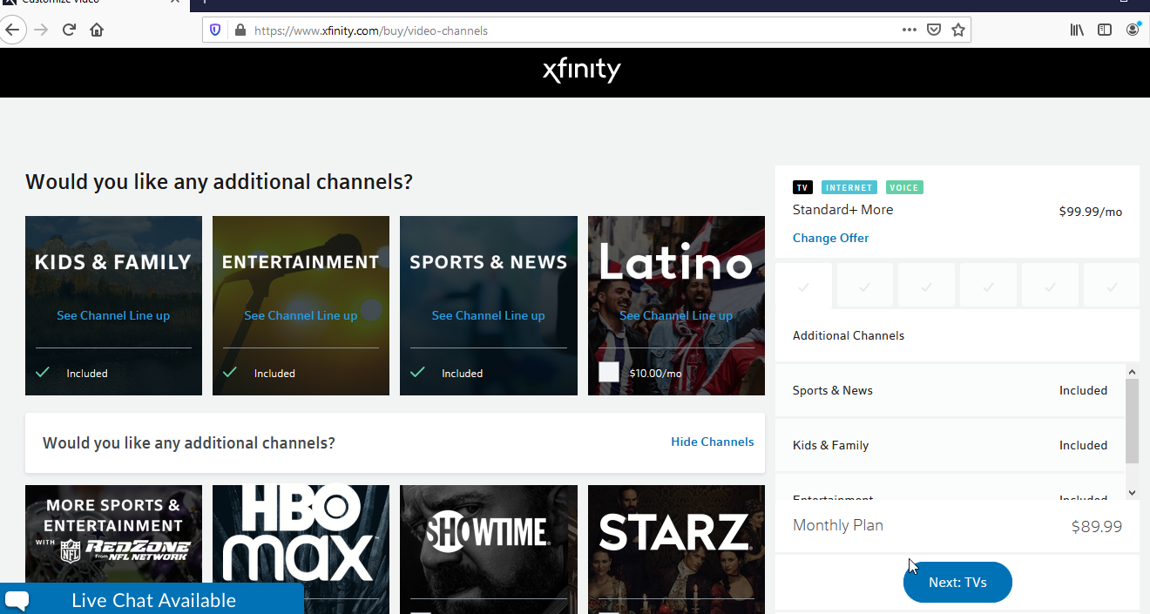

1. List out in words what are all the possible test cases youj will add for this particular page - <https://www.xfinity.com/buy/video-channels>. (Note: actual test scripts are not required for this step. Just the list of test cases which you will cover for this page should be good enough.)

**Optional Requirement**

1. Using testscripts, select the mandatory selection options and proceed till <https://www.xfinity.com/buy/billing> page.